PERIOD: _________
- Write Formula -----
- Substitute Values given into Formula.
- Find the missing value.
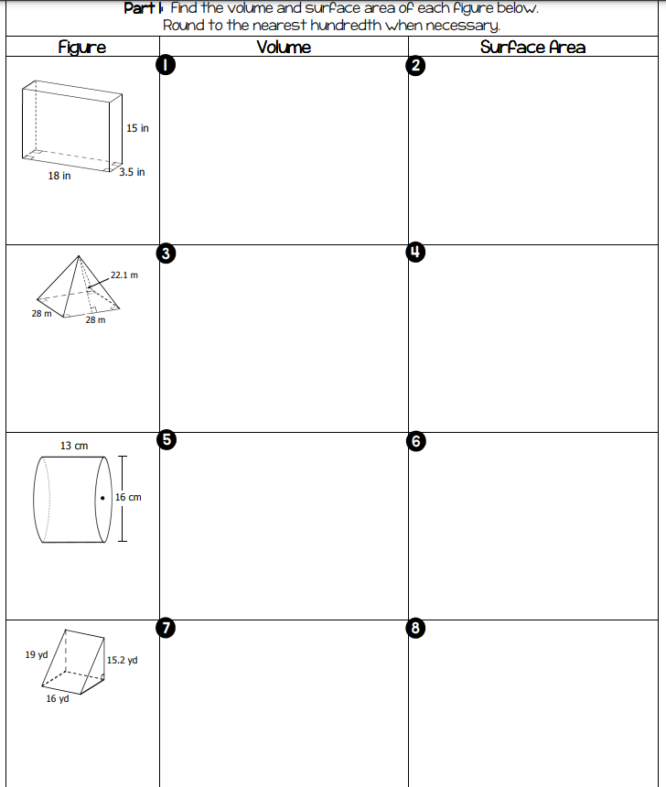

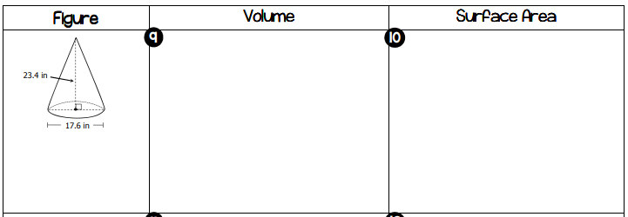
APPLICATION
10) b--
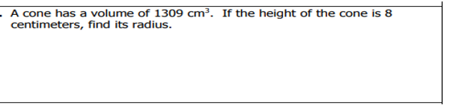
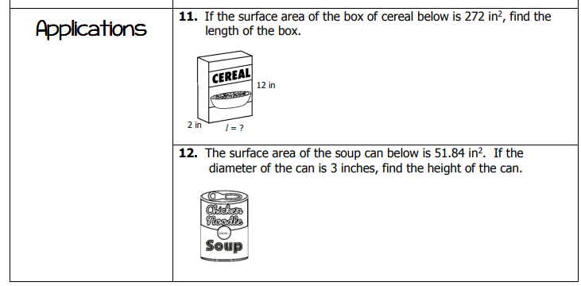
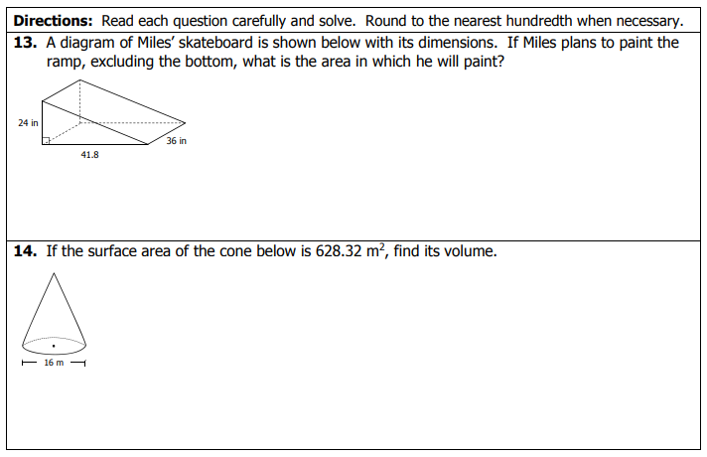
15) CHALLENGE:
