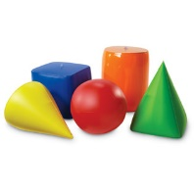
CH-12 3d introduction vocabulary – Define each word and make a sketch.
WORD | DEFINITION | SKETCH
Polyhedron
Vertex
Face
Edge
Lateral edge
Base edge
Right prism

Right cylinder

Oblique prism

Oblique cylinder

Pyramid

Height (of a prism/pyramid)

Slant height (of a pyramid/cone)

Cone

Sphere

Hemisphere

Cross section

Great Circle

Net

