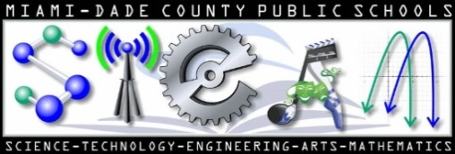
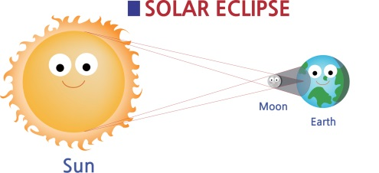
Scientific Investigation

Names of students in group: _____________________________ _____________________________

_____________________________ _____________________________

Describe how a partial sun eclipse is produced. Include what branch(es) of Science are related to eclipses? Explain. Make this research interesting. List all sources used at the bottom (bibliography)

