Sec [1.3] Pythagorean THM Intro [SHOW ALL WORK FOR CREDIT
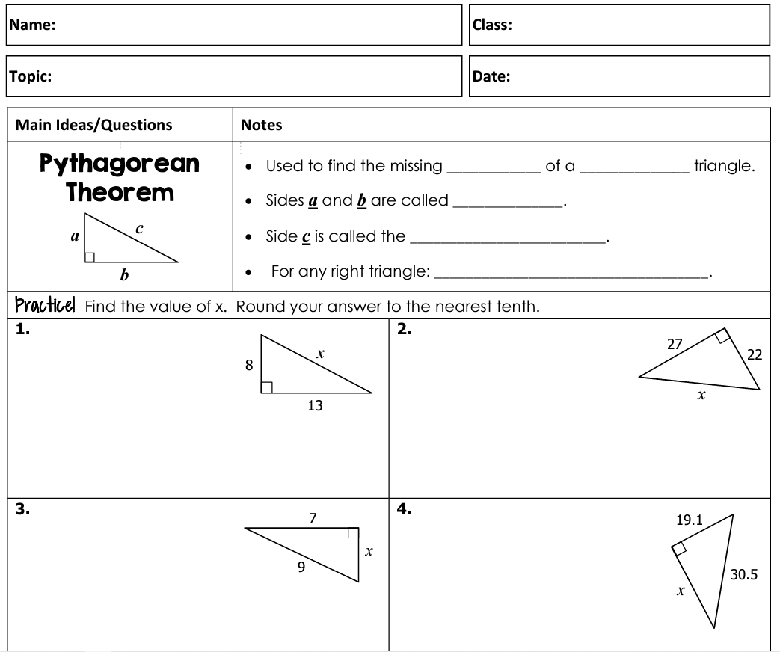
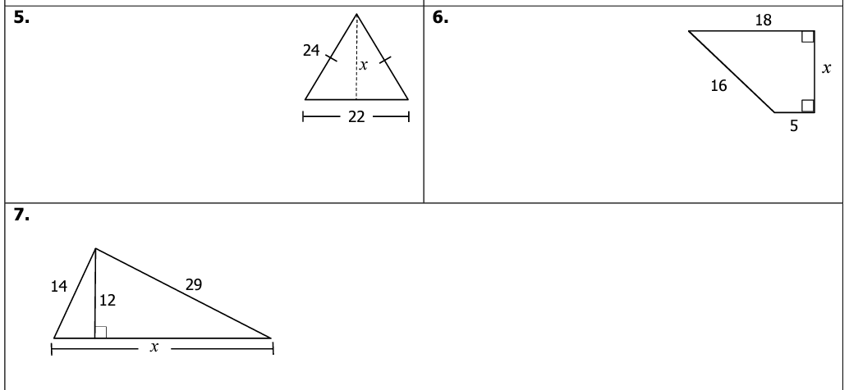
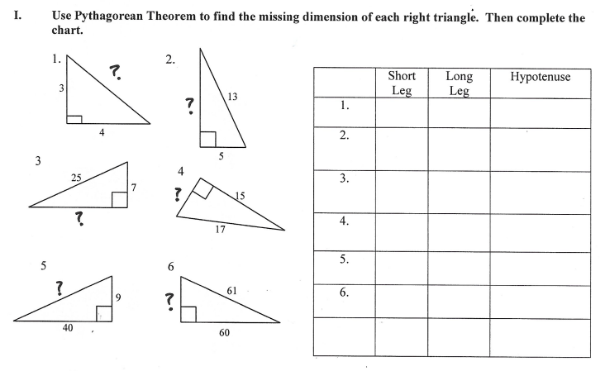
Show work for [6] problems below Number your work & fill in the table.

