Centers of a Triangle Practice Name:____________________ Period:____
Please complete the table below. SHOW YOUR WORK!
 | Drawing | Construction
Incenter  (3 angle bisectors)  Note: Construct  the inscribed circle too. Don’t forget to show your work for the radius. | 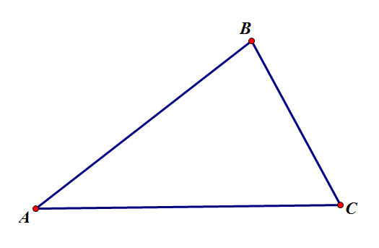
Circumcenter

(3 perpendicular bisectors)

Note: Construct
the circumscribed
circle too.
 | Drawing | Construction
Orthocenter

(3 altitudes)
Centroid

(3 medians)

Center of Gravity

